****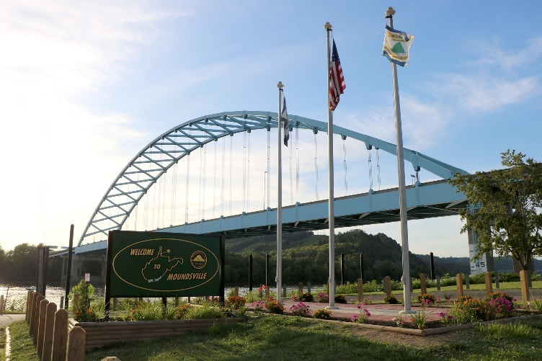

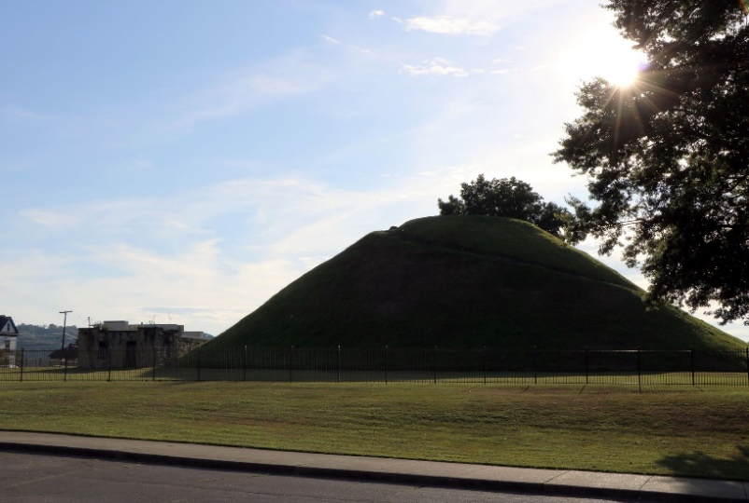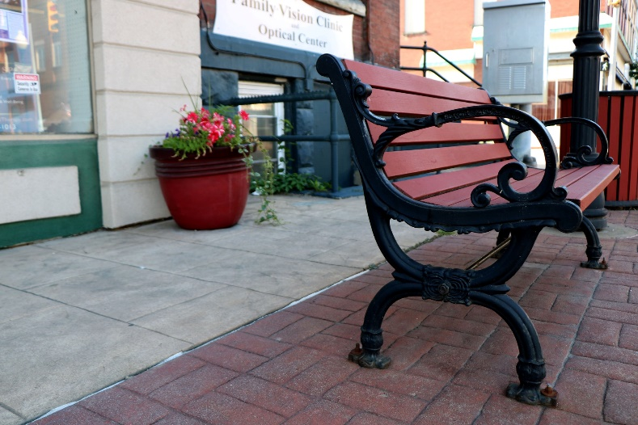

New Business

Welcome Packet

# CONTENTS

Letter from City Manager

Letter from City Clerk

Municipal Directory

City Council/Department Contacts

Letter from Building Inspector

City of Moundsville Zoning Map

Zoning Review Application

Before You Begin

Zoning Compliance

Building Permits

Contracted Work

Signs

Permit Inspection

Occupancy Inspection

Certificate Occupancy

Business License

Business & Occupation Tax

Pre-Inspection Check List

Glossary

Emergency Contact Information

Application for Zoning and Occupancy Permit

Development Permit Application

Sanitation and Dumpster Service

Commercial Sanitation Service Application

Business License Application

Business and Occupation Tax Return Form

Important Contacts

Utility Contacts

Community Quick Facts

Letter from Moundsville Water and Sanitary Boards

Water and Sanitary Board Application

Notes

Business Cards



City Clerk 304-845-3394

City Manager 304-845-6300

Fire Department 304-845-2050

Dear Business Owner,

Welcome, and thank you for choosing Moundsville as a location for your business. You will find it to be a great place to thrive and become part of this growing business community.

The purpose of this booklet is to make your business start-up or expansion an understandable and pleasant one. It will give you points of contact for all necessary city employees and other parties that you may need, blank forms for all business and construction needs, as well as a path to your opening.

During this process, should you encounter any problems, or questions that are unanswered, please feel free to contact me at any time. I can be reached via e-mail at [rhealy@cityofmoundsville.com](mailto:rhealy@cityofmoundsville.com), or by phone at 304-845-6300. I am always available to help.

In the end, we love to work with the Marshall County Chamber of Commerce to coordinate a ribbon cutting or grand opening celebration. Congratulations on this venture, and I look forward to seeing you soon.

Sincerely,

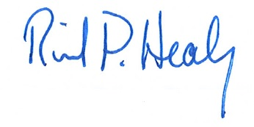

Richard P. Healy

City Manager

CITY BUILDING – 800 6th Street, P.O. Box E, Moundsville, WV 26041



City Clerk 304-845-3394

City Manager 304-845-6300

Fire Department 304-845-2050

Dear Business Owner,

The City of Moundsville is pleased to accommodate you with your new business venture. The City Clerk and office staff are available to assist and guide you through every step and to ensure your business meets the requirements of municipal and state government. We hope to make this an easy and enjoyable experience.

We think you will find this booklet to be very informational. It explains planning and zoning regulations, building permits and inspections, occupancy permits and city business licenses as well as council members, department contacts and phone numbers.

Let us know how we can help you by reaching out to us at [shewitt@cityofmoundsville.com](mailto:shewitt@cityofmoundsville.com) or [www.cityofmoundsville.com](http://www.cityofmoundsville.com).

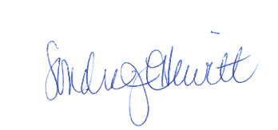Sincerely,

Sondra J. Hewitt

City Clerk

CITY BUILDING – 800 6th Street, P.O. Box E, Moundsville, WV 26041

# Municipal Directory

Open

Monday – Friday 8:00 AM – 4:30 PM

800 Sixth Street

Moundsville, WV 26041

www.cityofmoundsville.com

Phone: 304-845-3394

Fax: 304-845-7130

City Hall

*City Officials*

City Manager Rick Healy

304-845-6300

[rhealy@cityofmoundsville.com](mailto:rhealy@cityofmoundsville.com)

City Clerk Sondra Hewitt

304-845-3394

[shewitt@cityofmoundsville.com](mailto:shewitt@cityofmoundsville.com)

Finance Director Karen Ankrom

304-845-6300

[kankrom@cityofmoundsville.com](mailto:kankrom@cityofmoundsville.com)

Treasurer Lacey Williams

304-845-3394

[lwilliams@cityofmoundsville.com](mailto:lwilliams@cityofmoundsville.com)

Building Inspectors Joe Richmond, 304-830-1874

Office: 304-845-3394 [joerichmond@cityofmoundsville.com](mailto:joerichmond@cityofmoundsville.com)

Buddy Smith, 304-830-1875 [bsmith@cityofmoundsville.com](mailto:bsmith@cityofmoundsville.com)

Danielle Harmon, 304-830-1876

dharmon@cityofmoundsville.com

Public Works Director Lewis DeVault II

304-845-3511

[ldevault@cityofmoundsville.com](mailto:ldevault@cityofmoundsville.com)

Parks & Recreation Director John White

304-845-7733

[jwhite@cityofmoundsville.com](mailto:jwhite@cityofmoundsville.com)

Police Chief Tom Mitchell

304-845-1611

[tmitchell@moundsvillepd.com](mailto:tmitchell@moundsvillepd.com)

Fire Chief Gary Brandon

304-845-2050

[gbrandon@cityofmoundsville.com](mailto:gbrandon@cityofmoundsville.com)

Sanitary Superintendent Brock Castilow

304-845-4360

[bcastilow@moundsvillewwtp.com](mailto:bcastilow@moundsvillewwtp.com)

Water Superintendent Terry Roberts

304-845-3028

[troberts.water@aol.com](mailto:troberts.water@aol.com)

# City Council Members

Mayor (Ward 2) David Wood

Vice-Mayor (At Large) Sara Wood-Shaw

Ward 1 Dennis Hall

Ward 3 Eugene Saunders

Ward 4 Ginger DeWitt

At-Large Randy Chamberlain

At-Large Don DeWitt

Meeting Dates

City Council: Meetings are held on the first and third Tuesday of each month at 6:00 PM in the Council Chambers of the Municipal Building located at 800 Sixth Street.

Sub-Committee: Meetings are held on the second Tuesday of each month at 5:00 PM in the Council Chambers of the Municipal Building located at 800 Sixth Street.

Planning Commission: Meetings are held on the third Wednesday of each month (as needed) at 5:30 PM in the Council Chambers of the Municipal Building located at 800 Sixth Street

Board of Zoning Appeals: Meetings are held on the first Wednesday of each month (as needed) at 6:30 PM in the Council Chambers of the Municipal Building located at 800 Sixth Street

Departments & Phone Numbers

Sanitary/Stormwater Department

304-845-4360

Water Department/Billing

304-845-0380

Water Plant

304-845-3028

Public Works Department

(Street, Recycling, and Garbage)

304-845-3511

City Manager’s Office

304-845-6300

City Clerk’s Office

304-845-3394

Police Department

304-845-1611

Fire Department

304-845-2050

Parks & Recreation

304-845-7733



City Clerk 304-845-3394

City Manager 304-845-6300

Fire Department 304-845-2050

Dear Business Owner,

Thank you for choosing our community for your business endeavor. I would like to take this opportunity to welcome you to the city of Moundsville, West Virginia. The Building Department is excited to partner with you to ensure the success of your business here in our city. We are eager to help and hope we can make this process as smooth as possible.

A few items to note before you begin:

* Any offer to lease or purchase property should be contingent on the premises meeting the current WV State Building Code, WV State Fire Code, and any special codes/ordinances which govern your particular business (i.e. health codes).
* Codes change and a change in occupancy or ownership may require that the premises be brought up to the current codes. A business may wish to work with a design professional knowledgeable about these codes to assure that the code requirements are met.
* Please take note that the type of business you intend to conduct may require changes to the business premises. A licensed contractor may be required to make changes to a commercial building if the work involves structural, electrical, plumbing, mechanical or other non-cosmetic alterations. While the city cannot recommend any particular contractor, the Building Department has a list of licensed contractors available to you.
* If you decide to do some of the interior changes yourself, please keep in mind that a permit will still be required and all work performed must meet the current building code.
* We would be more than happy to schedule a pre-inspection of the space, so that we can all be on the same page throughout your project.

We look forward to working alongside you and are eager to foster a successful partnership. Please feel free to contact us with any questions you have at (304) 845-3394.

Sincerely,

Joseph Richmond II

**City of Moundsville**

Building Official

CITY BUILDING – 800 6th Street, P.O. Box E, Moundsville, WV 26041

# City of Moundsville Zoning Map

For most up to date zoning map, refer to website: [www.cityofmoundsville.com](http://www.cityofmoundsville.com)

# Zoning Review Application



Is your business a permitted use, a conditional use, or non-permitted use? (All uses not listed under the other two categories of the code are non-permitted uses.) If you are unsure, please contact the **Building Department**.

Pick up and fill out an Application for a Zoning and Occupancy Permit in the **Building Department**. A Building Inspector can be reached at 304-845-3394.

The **Building Department** will review your application and verify that you are a permitted use. If confirmed, your application will be approved. If not, they will discuss the next step.

If approved, start from the top and proceed as a permitted use.

**Planning Commission** recommendation moves to City Council. The final decision on a zone change is made by the **City Council**.

Pick up and fill out a Petition to the **Board of Zoning Appeals** at the **Building Department**

Meet with the **Board of Zoning Appeals** to review your application. The Board is empowered to make a final decision on conditional uses

Once approved, meet with the **Building Department** to schedule inspections and obtain your Certificate of Occupancy

Pick up and fill out a Planning Petition at the **Building Department**

Meet with the **Planning Commission** to petition for recommendation to Council.

Non-Permitted Use

Conditional Use

Permitted Use

# Before You Begin

Before opening a new business, or relocating an existing business within the City of Moundsville, the developer and/or business owner must submit details of the project to the Building Department. Staff can provide you with a New Business Information and Welcome Packet. They will collect any preliminary project plans, drafts, and/or information from the owner/developer. At this point the complexity and summary of the project will be known. Staff will then schedule the Preliminary Site Plan Meeting with the appropriate departments (i.e. Building, Stormwater, Police, Fire, Utilities, and Street Departments) if necessary.

# Zoning Compliance

Before you purchase or lease a space for your business in Moundsville, please contact the Building Department to ensure that your proposed business is permitted in the zoning district you intend to occupy. A Zoning Permit must be issued before you can move forward with your project. The Zoning Officer will review your application and determine whether the type of business you plan to open is a permitted, conditional, or not-permitted use in that district.

If your business is a permitted use, you will be issued a Zoning Permit and you may move forward with your project. If your business is listed as a conditional use, you must petition the Board of Zoning Appeals for a Conditional Use Permit. Please fill out the form as completely and accurately as possible, as approval of the application will be based on the information you provide.

# Building Permits

After the Zoning Permit is issued, you can apply for any Building Permits needed to get the building ready for your business. If this will be a new construction project, the Building Inspector will provide you with a new construction information packet.

A licensed contractor may be required to make changes to a commercial building if the work involves structural, electrical, plumbing, mechanical or other non-cosmetic alterations. The contractor will be required to obtain a City Contractor’s License and submit the Building Permit application, along with any drawings, plans, or other required documentation.

A property owner, or the owner of a tenant business may be allowed to perform some of the work on a commercial structure. In this case, the property or business owner will submit the Building Permit application and any required documentation.

Some commercial projects will require plans review and inspections by the West Virginia State Fire Marshal Plans Review Section. Forms and information on their process can be found at:

<https://firemarshal.wv.gov/Divisions/Fire_Inspections/Pages/Plans-and-Review-Division.aspx>

It is very common, while working on a project, to find additional items that you want to, or need to address. It is very important not to exceed the scope of work authorized by the permit you have. If you find any changes, additions or alterations to the work are necessary, please contact the Building Inspection office to have your current permit amended or to have an additional permit issued. Exceeding the authorized scope of work may result in a failed inspection, which may cost you both time and money.

# Contracted Work

Contractors will be required to have a City of Moundsville Contractor’s License. Additionally, the State of West Virginia requires that all contractors doing contracted work costing $2,500.00 or more have a State Contractor License.

It is the responsibility of the Contractor to apply for and obtain all required building permits and pay a Business and Occupation Tax of 2% of the contract value at the time the permits are issued.

Any Sub-Contractor working on a project is required to apply for and obtain a building permit for the work that they are contracted for, as well as pay a Business and Occupation Tax of 2% of the contract value at the time the permits are issued for their portion of work.

# Signs

Once you have clearance to operate in your intended location, let us know if you intend to change any permanent signage at the site. Most permanent signage requires a Building Permit, and review by the Zoning Officer. Temporary signage for your new business such as banners, window signs, sandwich boards, flags, inflatable balloons and grand opening event signage do not require a permit but are regulated by size, type and duration. A guide to temporary signage is available from the Building Department.

# Permit Inspection

Although not mandatory, we encourage a walk-through by the Building and Fire Inspectors prior to starting your project. This walk-through can help identify items that need to be corrected before opening your business, which can save you valuable time and money. We ask for a minimum 24-hour notice when scheduling inspections. We will do our very best to accommodate you, even on short notice. Scheduling in advance will help us to be available when you need us, so that we do not slow down your project.

The following inspections are required for any work done to a commercial structure.

1. Foundations and Footings

2. Structural Framing Before Being Covered

3. Electrical Rough-in and Final

4. Plumbing Rough-in and Final

5. Final Inspection

Occupancy Inspection

An Occupancy Inspection is **required** before a City Business License will be issued. A walk-through by the Building & Fire Inspectors prior to purchasing, leasing, or starting your project can help identify items of concern that may need corrected, as well as giving the inspectors a chance to go over the scope of work for any renovations that are planned. When renovating older structures small changes can sometimes trigger large upgrade requirements. A pre-construction/purchase inspection can save you valuable time and money. Occupancy Inspections must be scheduled no later than a week before your target opening date, to allow time for any re-inspection’s. Please use the Occupancy Pre-Inspection Check List to avoid common violations that could delay your opening. When all work has been finished, you may schedule the Occupancy Inspection through the Building Department. This inspection will be done by the City Building Inspector and the City Fire Inspector. If an inspection by the State Fire Marshal or County Health Department are required, you must schedule them separately.

# Certificate of Occupancy

After passing the Occupancy Inspection, a Certificate of Occupancy will be issued for your business to operate from the inspected location. This certificate will be required to obtain your city business license from the office of the City Clerk. Keep in mind that if there are any changes to your business, such as relocation, expansion or change of ownership, you will need to update your certificate.

# Business License

*(Municipal Code 741)*

The final step in this process is obtaining a city business license. The Business License Application can be obtained in the City Clerk’s Office. The Building Inspection Department will provide the City Clerk’s Office with a copy of the Occupancy Certificate. The business license application along with the occupancy certificate and required State of WV business registration ([www.sos.wv.gov](http://www.sos.wv.gov)) is submitted to the City Clerk or her/his designee. The application and license fee are processed and a business license is provided to the business owner at that time. The business license must be posted for public view inside the business. Business license renewals must be submitted to the City Clerk’s Office before July 1 of each year. All city fees and taxes must be current before a business license is processed. For information or questions, please contact the City Clerk’s Office at 304-845-3394.

# Business & Occupation Tax

*(Municipal Code 745)*

Business and Occupation Tax is a privilege tax based on the gross sale of tangible property without any deduction on account of the cost of property sold or expenses of any kind. The forms are sent to each business on a quarterly basis. Business classifications determine the rate of taxable sales. Most businesses are considered retail sales (Code 6). Individuals with rental property pay rental (Code 11). B&O taxes must be submitted to the City Clerk’s Office with payment. For information or questions please contact the City Clerk’s Office at 304-845-3394.

# Pre-Inspection Check List

Inspectors look at many items in your place of business. So that you may have a better understanding of what to keep an eye on, in regards to maintenance and safety, we have provided the following checklist. Note: *This list is a general guideline only for common violations that can be readily determined by the occupant*.

EXITS

Door/aisle is not obstructed.

Proper lock/hardware on the exit. (No flush bolts, hasps, etc.)

Exit doors open easily.

There is a sign over the main entrance, “This door is to remain unlocked during business hours,” if the door has a double-keyed deadbolt.

Illumination exit signs maintained in working order.

Means of egress shall be kept clear.

Emergency lights maintained and in working order.

Doors with panic hardware shall have no other locking devices.

Maximum occupancy signage shall be posted in a conspicuous location near the main entrance for assembly occupancies.

EXTENGUSIHER/FIRE PROTECTION EQUIPMENT

Minimum 2 ABC extinguisher(s) installed.

Extinguishers have been serviced within the past year and a new service tag is attached.

_Extinguishers have been inspected monthly W/ documentation.

Extinguishers are securely mounted or in an approved cabinet.

Fire extinguisher not obstructed.

Fire extinguisher top does not exceed 5 feet from floor when mounted.

Hood extinguishing system maintained, and yearly service and cleaning documented.

Class K extinguisher installed 10-20 feet from hood and duct system.

Fire alarm system is in proper working order- system tested annually- record of testing.

18 inches of clearance between storage and sprinkler heads.

Sprinkler system shall be maintained and tested annually.

Standpipe shall be tested every 5 years.

APPLIANCE/MECHANICAL

No propane used/stored in building.

All appliances are properly connected and vented.

ELECTRICAL

No extension cords in use in place of permanent wiring.

There are no spliced or frayed cords/ wires.

Spacer(s) in electrical panel gap(s) provided.

No broken or faulty switch/outlets.

No exposed wire in conduit.

No missing/broken electrical cover plate(s).

Electrical panel is not overloaded/ obstructed.

No multi-plug adapters in use, other than approved power strips.

Circuit breakers are labeled.

Electrical cords do not extend through walls, ceilings and floors, or under doors or floor coverings.

30 inches of clearance maintained in front of electrical panels.

STORAGE/ COMBUSTIBLE MATERIAL/ HOUSEKEEPING

Flammable liquid properly stored.

Oil rags in non-combustible container with lid.

“No Smoking” signs installed as required.

No combustible material stored near ignition source.

Maintain clear and visible access to and around FDC (fire department connection).

No accumulation of combustible materials.

Compressed gas cylinders secured.

Flammable gas cylinders stored properly.

Area around building free of combustible materials.

No storage shall be kept in exit stairways/ hallways.

Fire and smoke walls shall be maintained and have no opening other than those allowed by code.

Ceiling tile installed properly with no missing or broken tile.

MISCELLANEOUS

Fire lanes shall be approved by Fire Department.

Address numbers shall be posted in contrasting colors on the front and rear doors for commercial businesses and shall be 8 inches on the front door, and 4 inches on the back door. All other structures shall be 4.

Rapid key entry box (Knox Box). located near main door.

# Glossary

**Board of Zoning Appeals (BZA)** A quasi-judicial body that approves land-use actions like Conditional Use and Variance applications.

**Certificate of Occupancy** A document required prior to occupying any commercial building, storefront, or other structure. Contact the Building Department for details.

**Conditional Use** A zoning exception that allows a property owner use of his/her land in a manner not otherwise permitted within that particular zoning district. Call the Building Department for details.

**Facade** The front or face of a building, especially the side that faces the street.

**Historic and Neighborhood** A special local district whose borders are defined in the

**Commercial District** included map that has special regulations to ensure the preservation of the exterior of the buildings.

**Land Use** The classification of current and future activities permitted or desired to occur within a natural or built environment.

**Mixed-Use Development** A type of development that has two or more zoning uses. For example, if you want to rent out the second floor of your business as an apartment, you have a residential use plus a commercial use on the ground floor.

**Set-Back** The distance a fence, building, or other structure must be behind a street, lot line or other important public asset.

**Site Plan** A detailed plan of the current and envisioned site which includes land use, traffic impact, utility impact, urban design principals, public-safety services and landscaping. Contact the Building Department for details.

**Use Variance Application** A document filed by the owner or owner’s authorized agent requesting authorization to conduct activities not otherwise permitted. Contact the Building Department for details.

**Zoning Review Application** A document that confirms a change of use (when the old business leaves the building and is replaced by another business).

**Zoning Variance** Authorization from the local government to allow a property owner to do something with his or her property that would otherwise not be permitted by the local zoning ordinance.

**City** **Clerk 304-845-3394**

**City Manager 304-845-6300**

**Fire Department 304-845-2050**

Dear Business Owner,

We would like to ask you to take just a few moments to fill out the following information. This information will allow us to better serve you and your business. By updating our files, the Moundsville Police Department will be better prepared to assist you in case of an emergency.

Once completed, simply return the form in person, mail or fax the form to: Moundsville Police Department, 800 Sixth Street, Moundsville, WV 26041, (fax) 304-843-1646.

Business Name____________________________________ Phone Number ________________________

Business Address _______________________________________________________________________

Business Owner/Manager ____________________________Phone Number ________________________

Owner/Manager Address _________________________________________________________________

Does the business have an alarm? (Y/N) _________

If Yes, with what company? _______________________ Phone Number ____________________________

Company Address ______________________________________________________________________

In case of an emergency, employees with whom to contact to secure the business:

Name________________________________________ Phone Number_____________________________

Address _______________________________________________________________________________

Name ________________________________________ Phone Number ____________________________

Address _______________________________________________________________________________

Any additional information you feel we may need to know such as night time janitors, late night deliveries, etc. __________________________________________________________________________________

______________________________________________________________________________________

______________________________________________________________________________________

We would like to thank you for your help in our endeavor to better serve our community and its people.

CITY BUILDING – 800 6th Street, P.O. Box E, Moundsville, WV 26041

# Sanitation and Dumpster Service

All businesses located in Moundsville are required to utilize the city’s sanitation services. A variety of options including dumpster type, size and frequency of pick-up times are available. The following is a brief outline of service rates:

A. Class I Commercial. (Those small offices which produce mainly paper waste and which do not use dumpsters): $19.52 per month.

B. Class II Commercial. (Those small commercial, business, or service establishments which do not use dumpsters): $25.41 per month.

C. Class III Commercial. (Those commercial, business, or service establishments which use dumpsters shall be charged the following rate times the cubic yard size of their dumpster(s) times the number of pickups made per week): $8.27 per cubic yard. Additionally, such customers shall be charged an annual dumpster rental fee of $100.00.

D. Class IV Commercial. (Those commercial, business, or service establishments which regularly dispose of bottles or other heavy items in addition to regular refuse, and which use dumpsters shall be charged the following rate times the cubic yard size of their dumpster(s) times the number of pickups made per week): $8.73 per cubic yard. Additionally, such customers shall be charged an annual dumpster rental fee of $100.00.

E. Class V Commercial. (Those larger commercial establishments requiring special accommodation to be negotiated and established by the City Manager based on Class III or Class IV rates.)

It is your responsibility as a business owner to contact the City Clerk’s Office at 304-845-3394 to apply for the service.



# Important Contacts

Marshall County Chamber of Commerce (Grand Openings) 304-845-2773

Marshall County Health Department 304-845-7840

Moundsville Post Office 304-845-0104

# Utility Information

American Electric Power 800-852-6942

Mountaineer Gas 800-834-2070

Comcast 855-432-3945

Frontier 800-921-8101

Dish Network 800-333-3474

DirecTV 800-531-5000

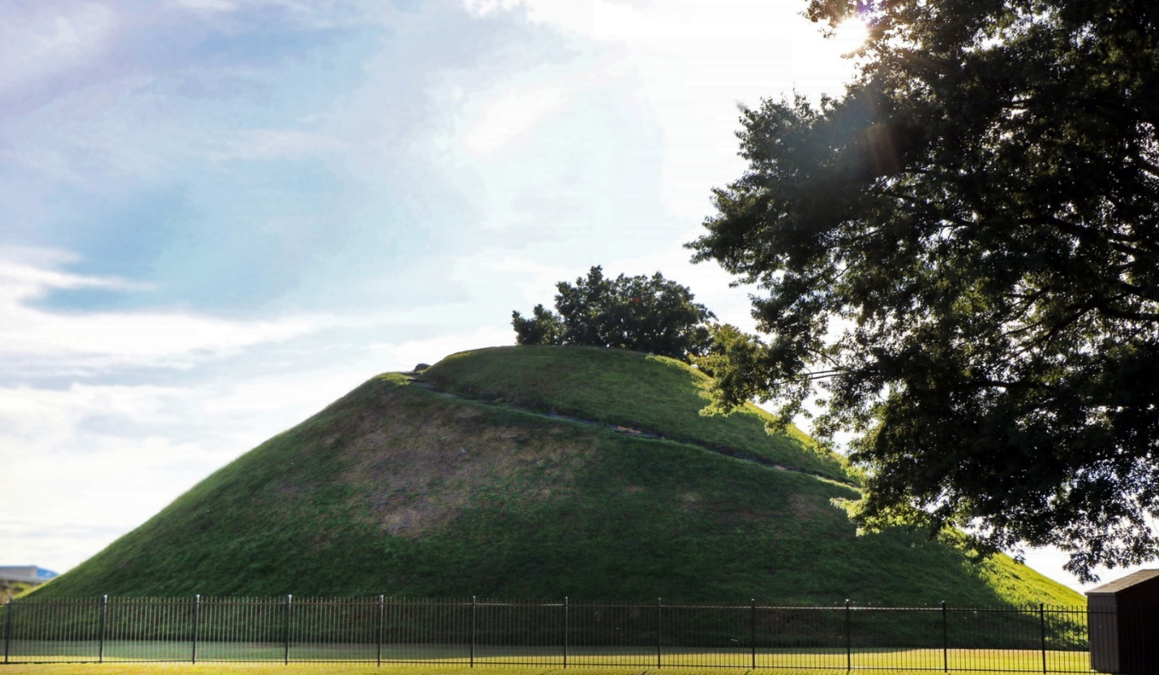

# Community Quick Facts

Moundsville is a small town nestled in the northern panhandle of scenic West Virginia. Moundsville is a growing family-based community rich in heritage and history. Deriving its name from the many Adena Indian burial mounds constructed more than 2000 years ago. Moundsville is home to the largest conical burial mound in North America. Moundsville is not only a land of sacred pasts, but of promising futures. Moundsville, WV is a melting pot of fine education, a strong blue-collar workforce, bountiful heritage and beautiful landscapes.

Population: 8,093 (2020 US Census)

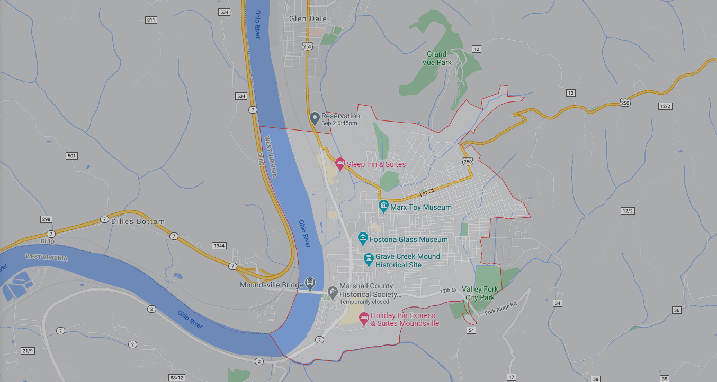

# NOTES

______________________________________________________________________________________________________________________________________________________________________________________________________________________________________________________________________________________________________________________________________________________________________________________________________________________________________________________________________________________________________________________________________________________________________________________________________________________________________________________________________________________________________________________________________________________________________________________________________________________________________________________________________________________________________________________________________________________________________________________________________________________________________________________________________________________________________________________________________________________________________________________________________________________________________________________________________________________________________________________________________________________________________________________________________________________________________________________________________________________________________________________________________________________________________________________________________________________________________________________________________________________________________________________________________________________________________________________________________________________________________________________________________________________________________________________________________________________________________________________________________________________________________________________________________________________________________________________________________________________________________________________________________________________________________________________________________________________________________________________________________________

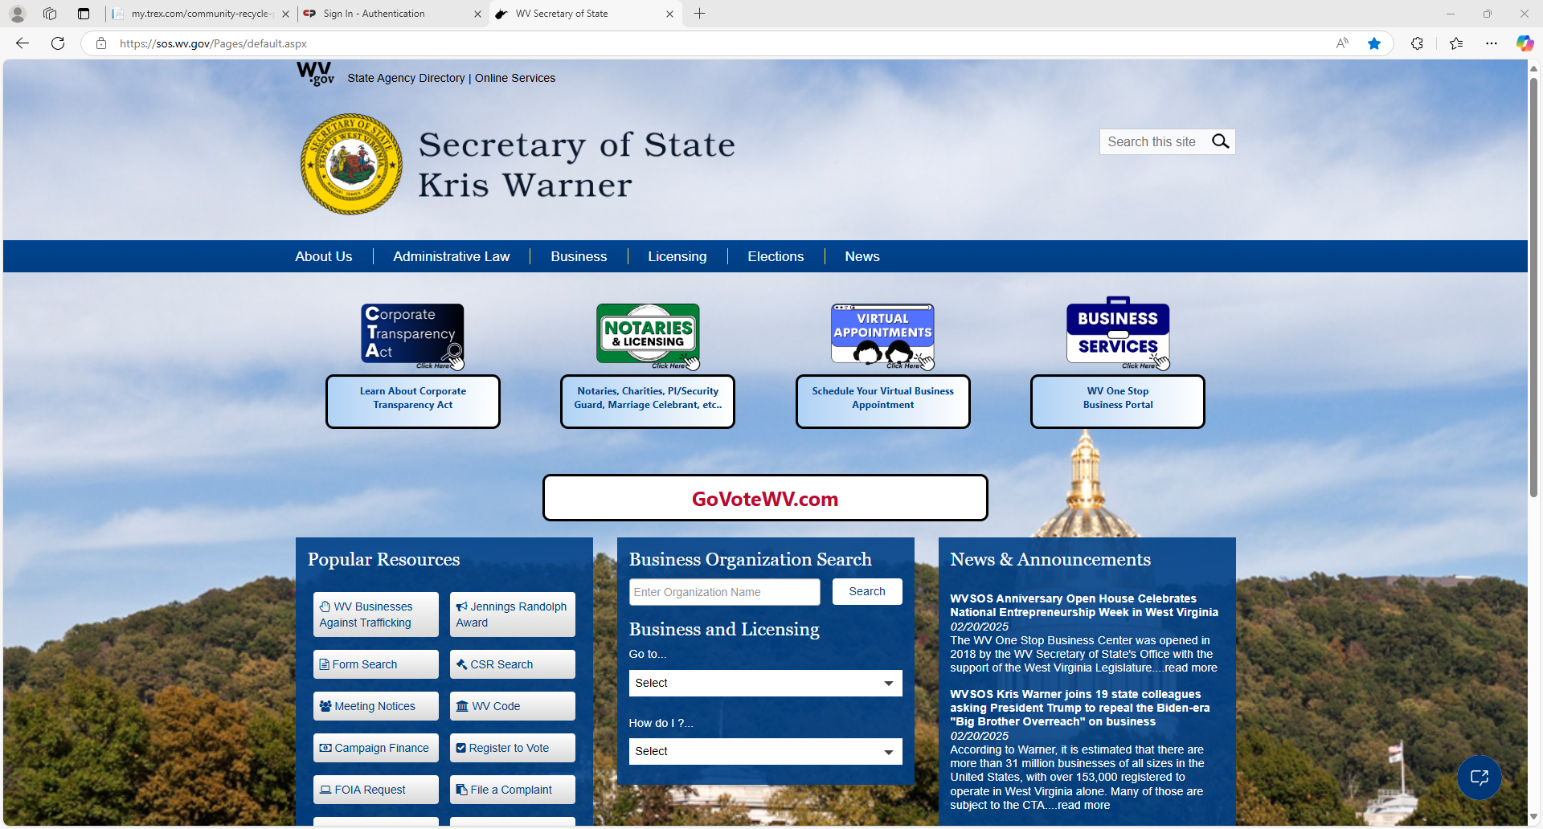

ACKNOWLEDGEMENT

Please sign below to acknowledge that you have been provided with a copy of the New Business Welcome Packet and that you have been instructed to read it.

_________________________________________________

First and Last Name (Please Print)

_________________________________________________

Signature

_________________________________________________

Name of Business

_________________________________________________

Physical Business Address

_________________________________________________

Business Mailing Address (If different from physical address)

_________________________________________________

Business Phone Number(s)

Offices that REQUIRE an Acknowledgement copy include:

Building Inspection Department

Data Processing Department