REQUEST FOR QUALIFICATIONS/ PROPOSALS

(RFQ/RFP # 2026-01)

DEVELOPMENT SERVICES

FOR PROPERTIES LOCATED AT
201, 227, 229 Jefferson Avenue

Tax Parcels 11-14-72, 11-14-73, & 11-14-77

City of Moundsville, West Virginia 26041

Proposals due
March 19, 2026, By 3:00 P.M.
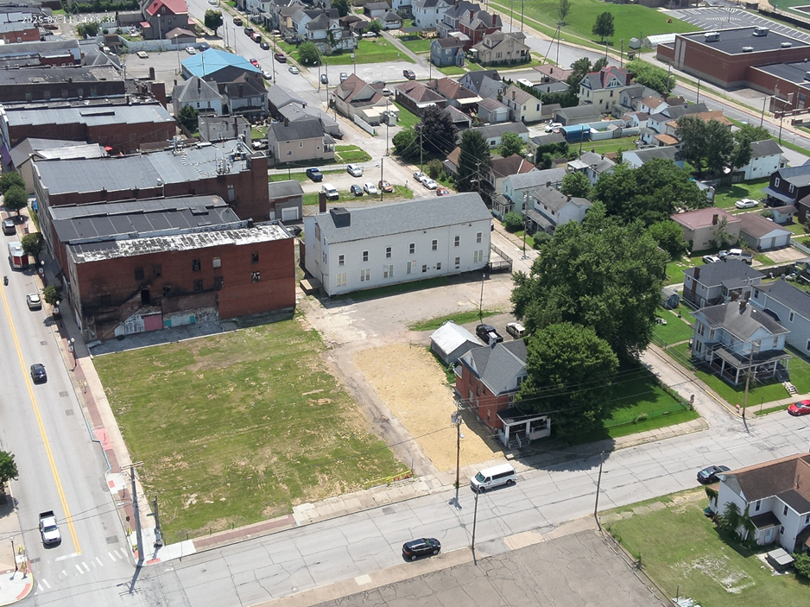

CITY OF MOUNDSVILLE, WEST VIRGINIA REQUEST FOR QUSLIFICATIONS/PROPOSALS
201, 227, 229 Jefferson Avenue
The City of Moundsville is accepting qualifications and proposals from developers for the sale and development of vacant land at 201, 227, 229 Jefferson Avenue. These adjacent parcels are in the Historic Business District on Jefferson Avenue and corner with Second Street (map attached). We are suggesting a multi-use approach of commercial and residential use for the site.
The site is in an Opportunity Zone, a New Market Tax Credit eligible census tract, and a BUILD WV district. The City of Moundsville also has a Business & Occupation Tax exemption, pro-rated for the first three years, in this district.
The City of Moundsville is located in the northern panhandle of West Virginia approximately eleven miles from Wheeling and Interstate 70. The in-city population is approximately 8,000. The population within a fifteen (15) mile radius is 115,342. Details, maps and pictures of the site are included with the RFP. The city is located along the Ohio River and West Virginia State Route 2, and US Route 250 transect the city.

SERVICES REQUIRED
The City of Moundsville, West Virginia is searching for a developer to purchase and develop vacant land located at 201, 227, and 229 Jefferson Avenue. These contiguous parcels are at the northern end of the Historic Business District which includes shopping and upper floor residential units. The approximate 0.55-acre parcel is currently owned by the City of Moundsville. The city is seeking a developer to provide a complete redevelopment of the vacant site, including design, construction, and leasing. The developer must provide a proposed site ownership/leasing structure for the site.

INFORMATION AND DATA REQUIRED OF EACH RESPONDENT

Description of the respondent's experience in undertaking projects similar to the one outlined within this Request for Proposals.

Demonstrate the respondent's experience relative to local codes, state and federal regulations applicable to the project.

Provide the names and statements of qualifications and professional credentials and licenses of the individual key staff members who will render the services requested.

Demonstrate the respondent's stability and continuity of staff and management.

Statement concerning the respondents’ ability to enter into a contract with the City of Moundsville.
- A conceptual site plan must accompany the proposal. The plan shall show at a minimum the building(s) location, size, heights, and setbacks; and the proposed parking layout, indicating total spaces.
- Financial expectations from the development of the site and/or from the city.

EVALUATION OF QUALIFICATIONS

The respondents will be rated on the following factors.

Qualifications/experience in working on developable sites.

Knowledge of local (e.g. building, zoning), state (e.g. ABCA, fire), and federal building regulations.

Experience and qualifications of personnel.

Demonstrate the respondent's stability and continuity of staff and management.

Stability and continuity of staff and management.
- Vision, ideas, and design specifications including potential layout of the project.
- Outline of tenant mix proposed and subsequently attracted to the site.
- Financial approach and model. Please include financial expectations from the development of the site and/or from the city.
- Timeline and expected completion of construction on the site.

RFP SUMMARY

Jefferson Avenue Redevelopment Project

The proposal must include at the minimum the following information:

Development Company Name

Primary Contact

Address

Phone Number

Email Address
- Financial model including expected contributions from the development of the site and/or from the city.

Developer Equity

Consultant(s)

Partner(s)

Contractor(s)

Acquisition Offer

Concept (including potential tenants)

Conceptual Site Plan

Indicate any potential variances from code needed for setbacks, parking, minimum area per dwelling unit, etc.

Include any potential approvals needed from City Council (ABCA), the Planning Commission (site plan) or other committee approvals (variances)

Total Estimated Project Cost

Total Residential Units

Total Retail Square Footage

Total Restaurant Square Footage

Total Office Square Footage

Other (Please Specify)

Project Timeline (Start Date/End Date)

SUBMISSION
Respondents shall submit original and one (1) copy (both shall be marked as such) of their proposal by 3 p.m. prevailing time on Thursday, March 19, 2026, to the following address:

Rick Healy, City Manager
City of Moundsville
800 6th Street
Moundsville, West Virginia 26041
Phone: (304) 845-6300
E-Mail: rhealy@cityofmoundsville.com

ATTACHMENT 1
MAP

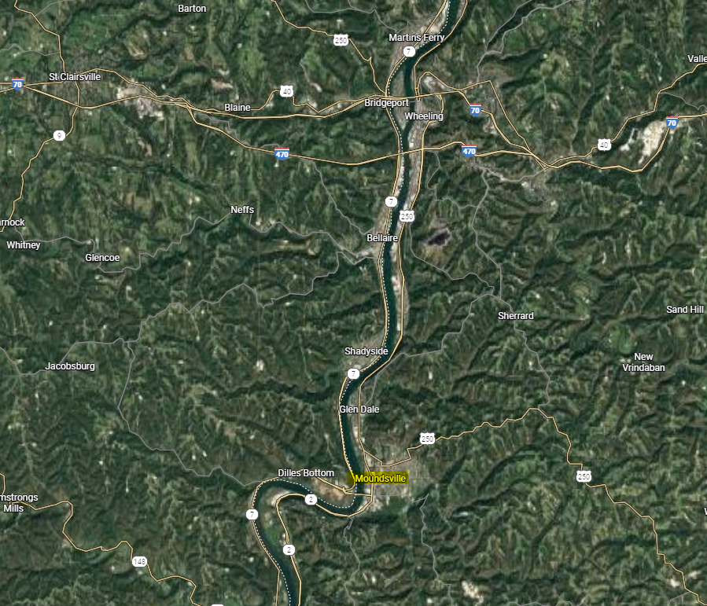

ATTACHMENT 2
MAP

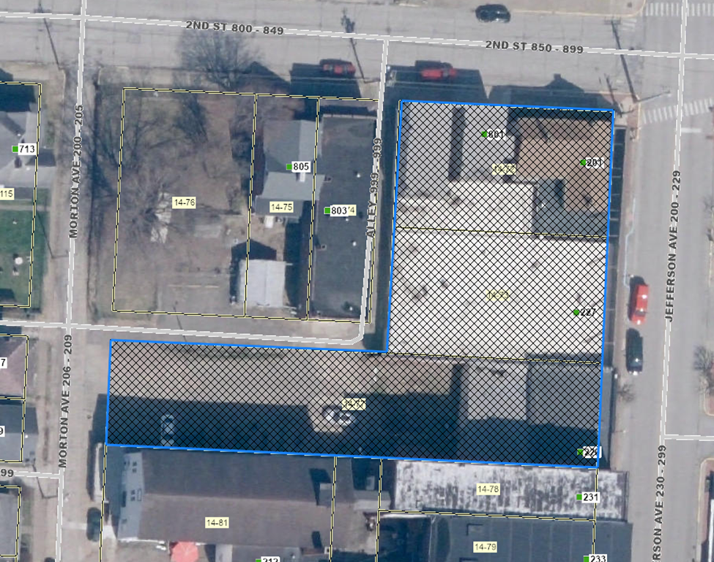

ATTACHMENT 3
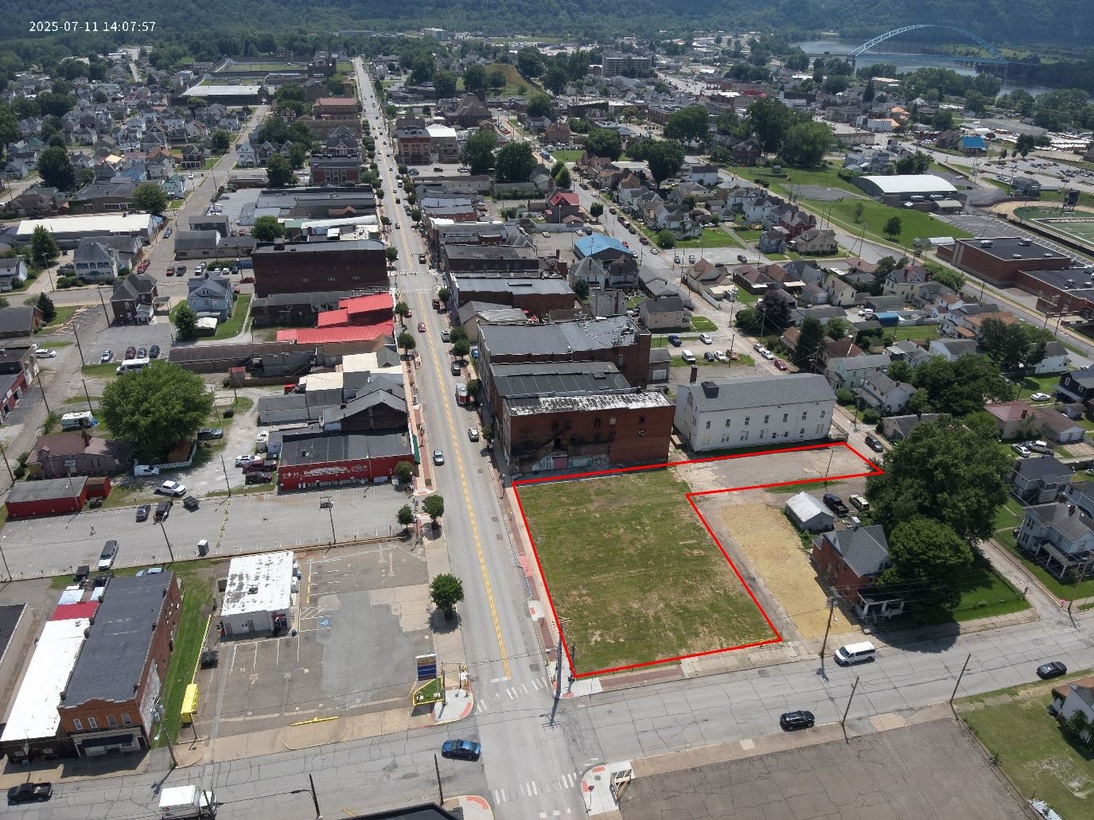
PHOTOS

Jefferson Avenue (US Route 250) looking south. This is the northern end of the Historic Business District and the On Trac District. The bridge in the upper right crosses the Ohio River to Dilles Bottom, Ohio. The historic Adena Burial Mound can be seen in the top middle of the picture.

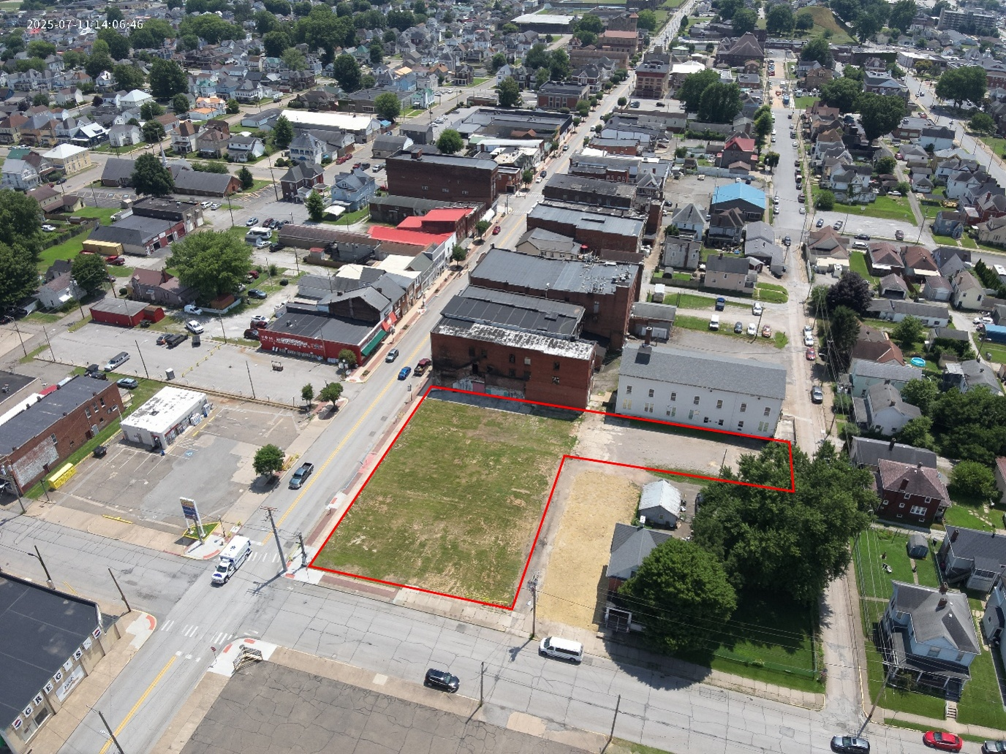

The intersection of Jefferson Avenue (US Route 250) and Second Street is in the lower left corner, with photo looking slightly southeast. A city owned parking lot can be seen across from the subject property. Directly south of the parking lot is retailer Ruttenbergs, who have been located in Moundsville since 1930.

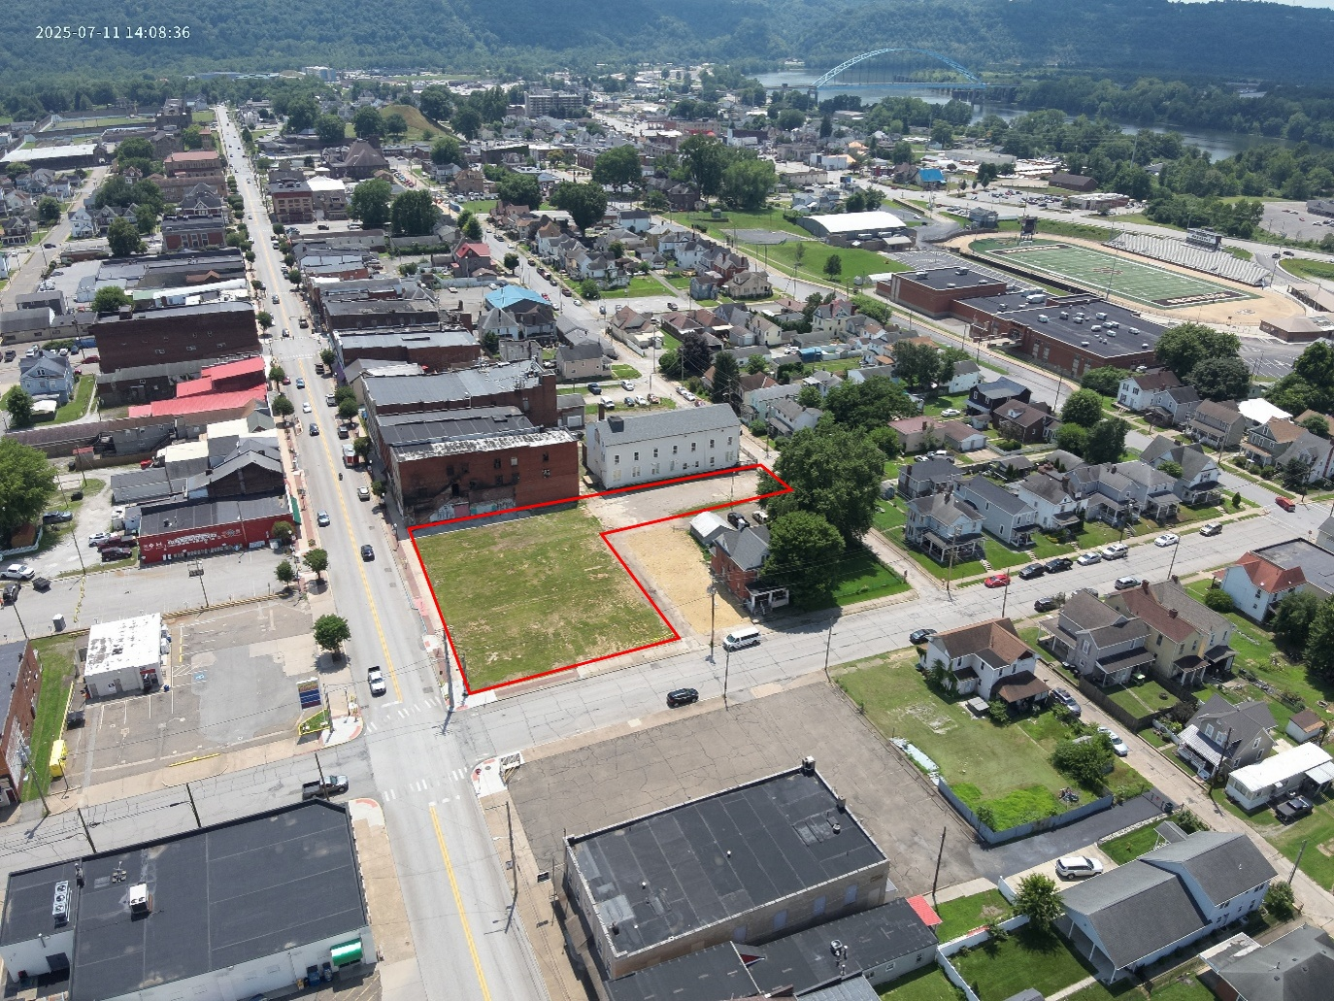

The intersection of Jefferson Avenue (US Route 250) and Second Street is in the lower left corner, with photo looking slightly southwest. The lower left corner is Greg’s Market, a grocery store that (under different names) has been a staple since 1939. In the upper right of the photo is the John Marshall High School football stadium and the rolling hills of both West Virginia and Ohio in the background.

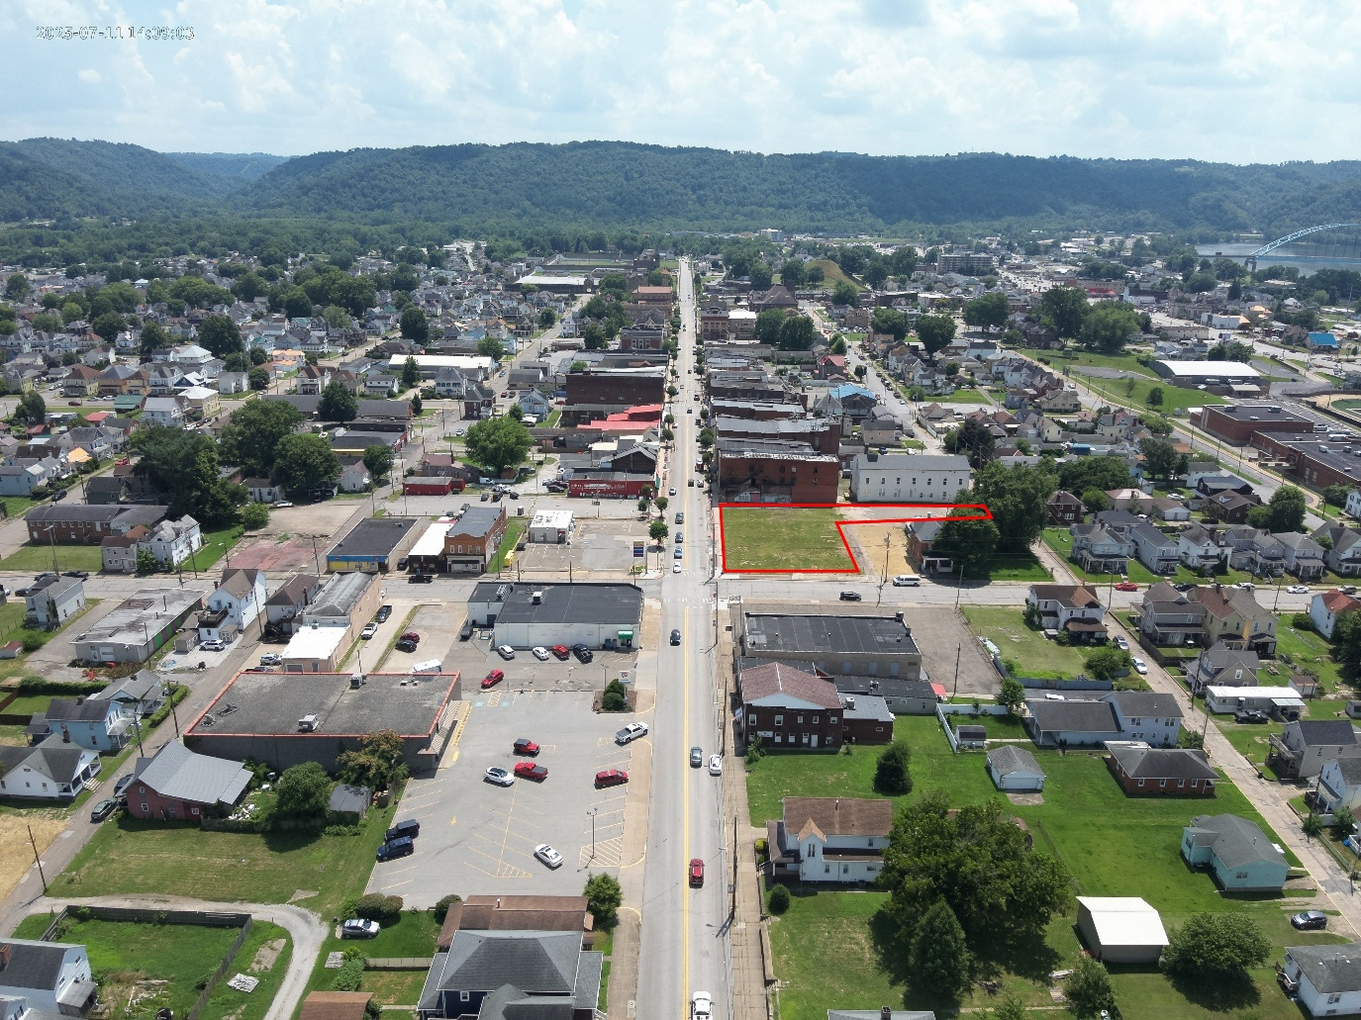

Jefferson Avenue (US Route 250) looking south. The subject property is in the center of the photo. This picture shows the quaint residential neighborhoods located within walking distance of the Historic Business District.

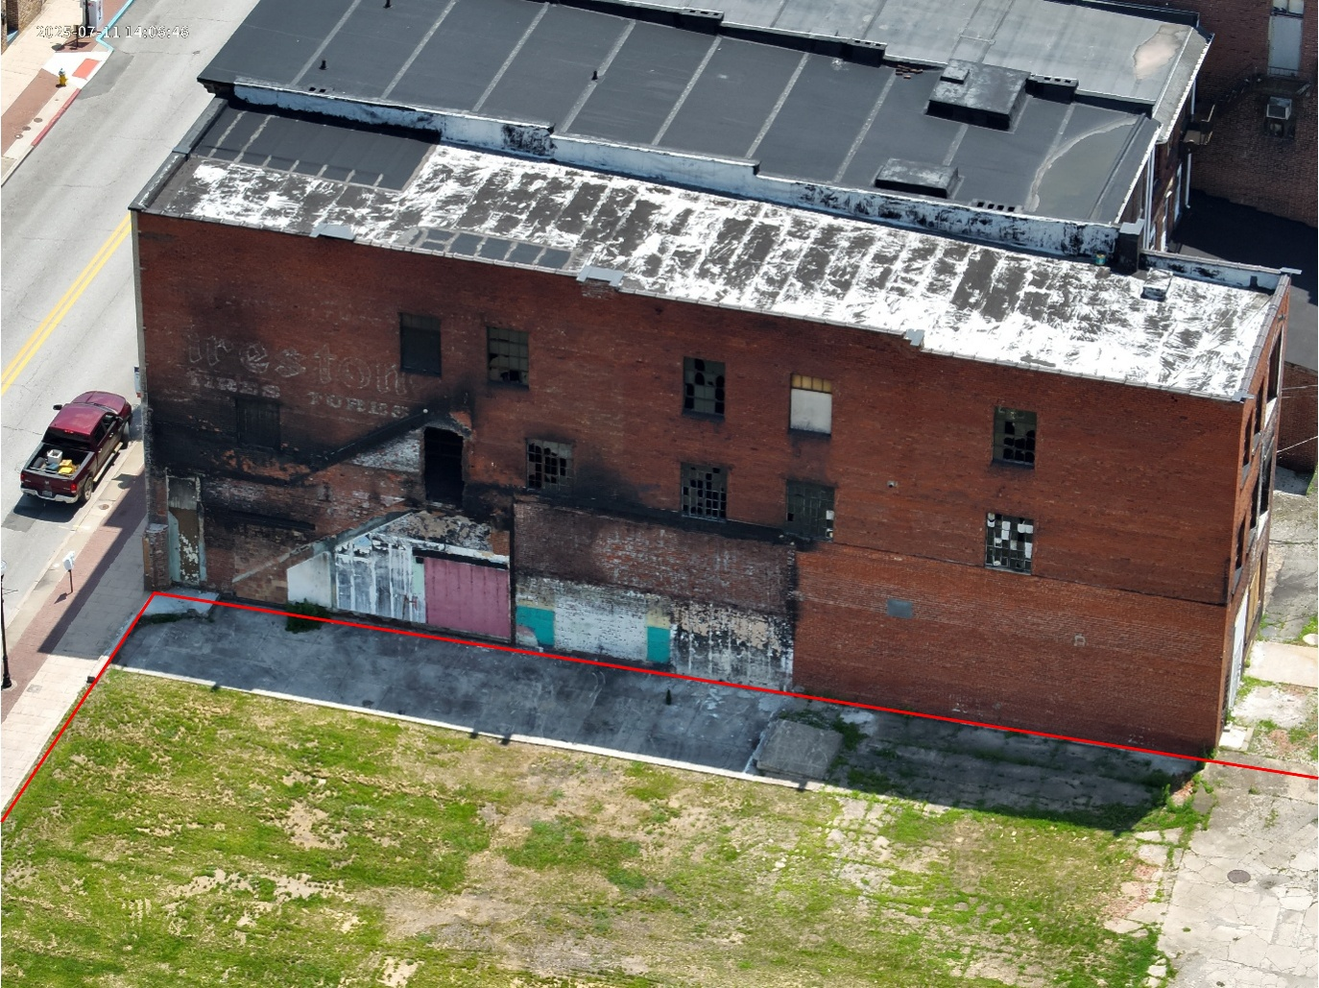

Street level view of the property (northern end), looking west from Jefferson Avenue.

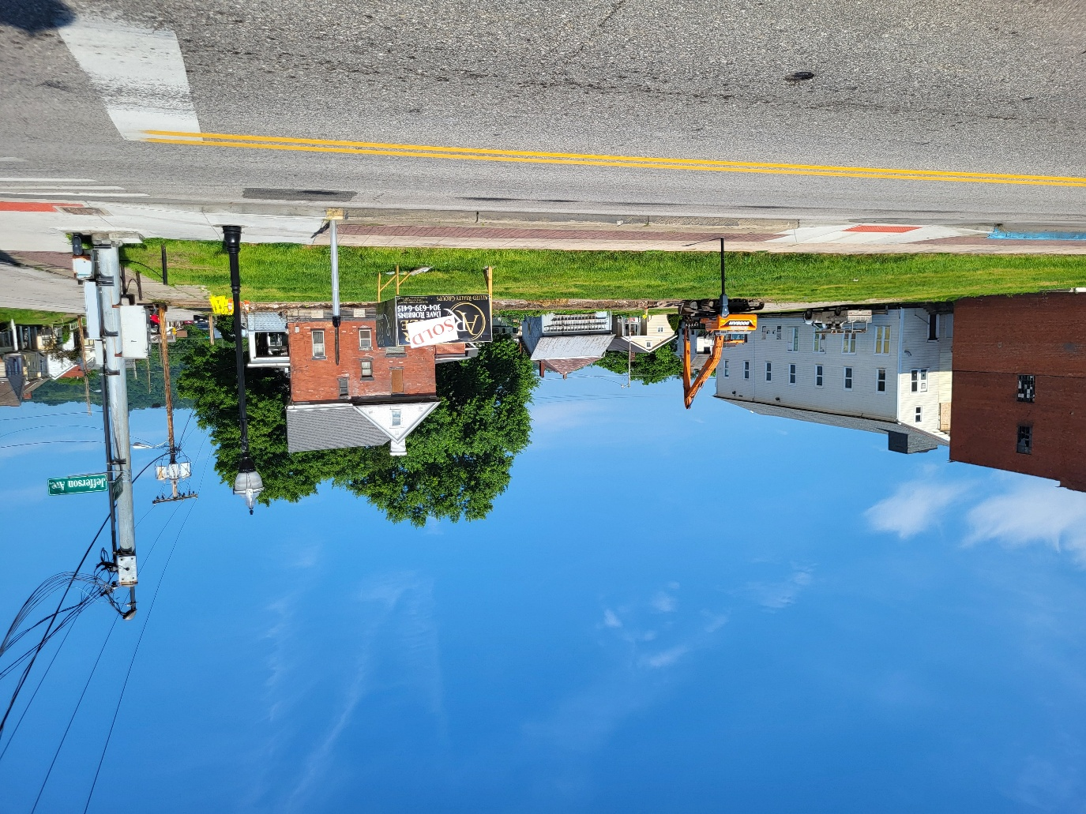

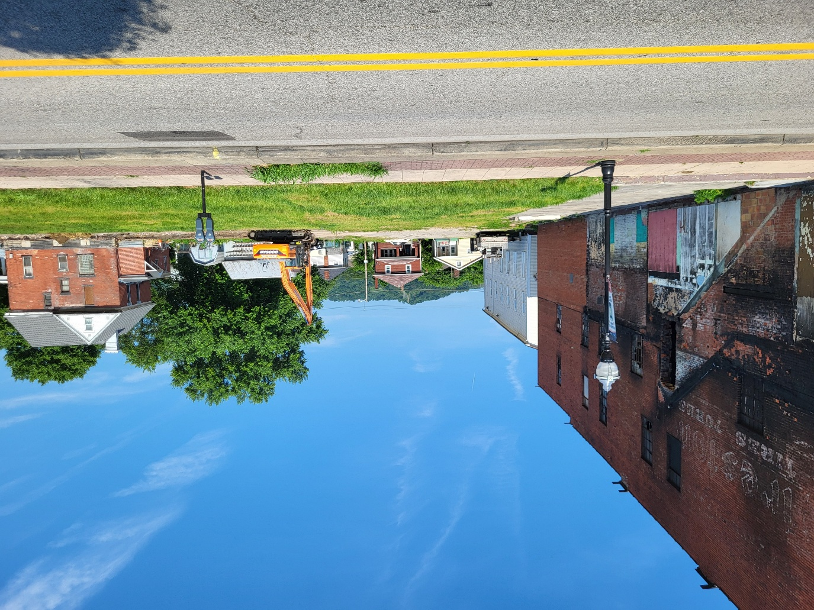
Street level view of the property (southern end), looking west from Jefferson Avenue. This building is currently under renovation.

Street level view of the property, looking west.

